## Acquiring New Targets

### Subtask 1

1. Use DNS Spoofing to redirect victim XP machine to your webserver. On your web server have a malicious iframe which targets internet explorer 6, as described in class.

You should submit screenshots showing the following

1. Successfully exploitation of IE 6

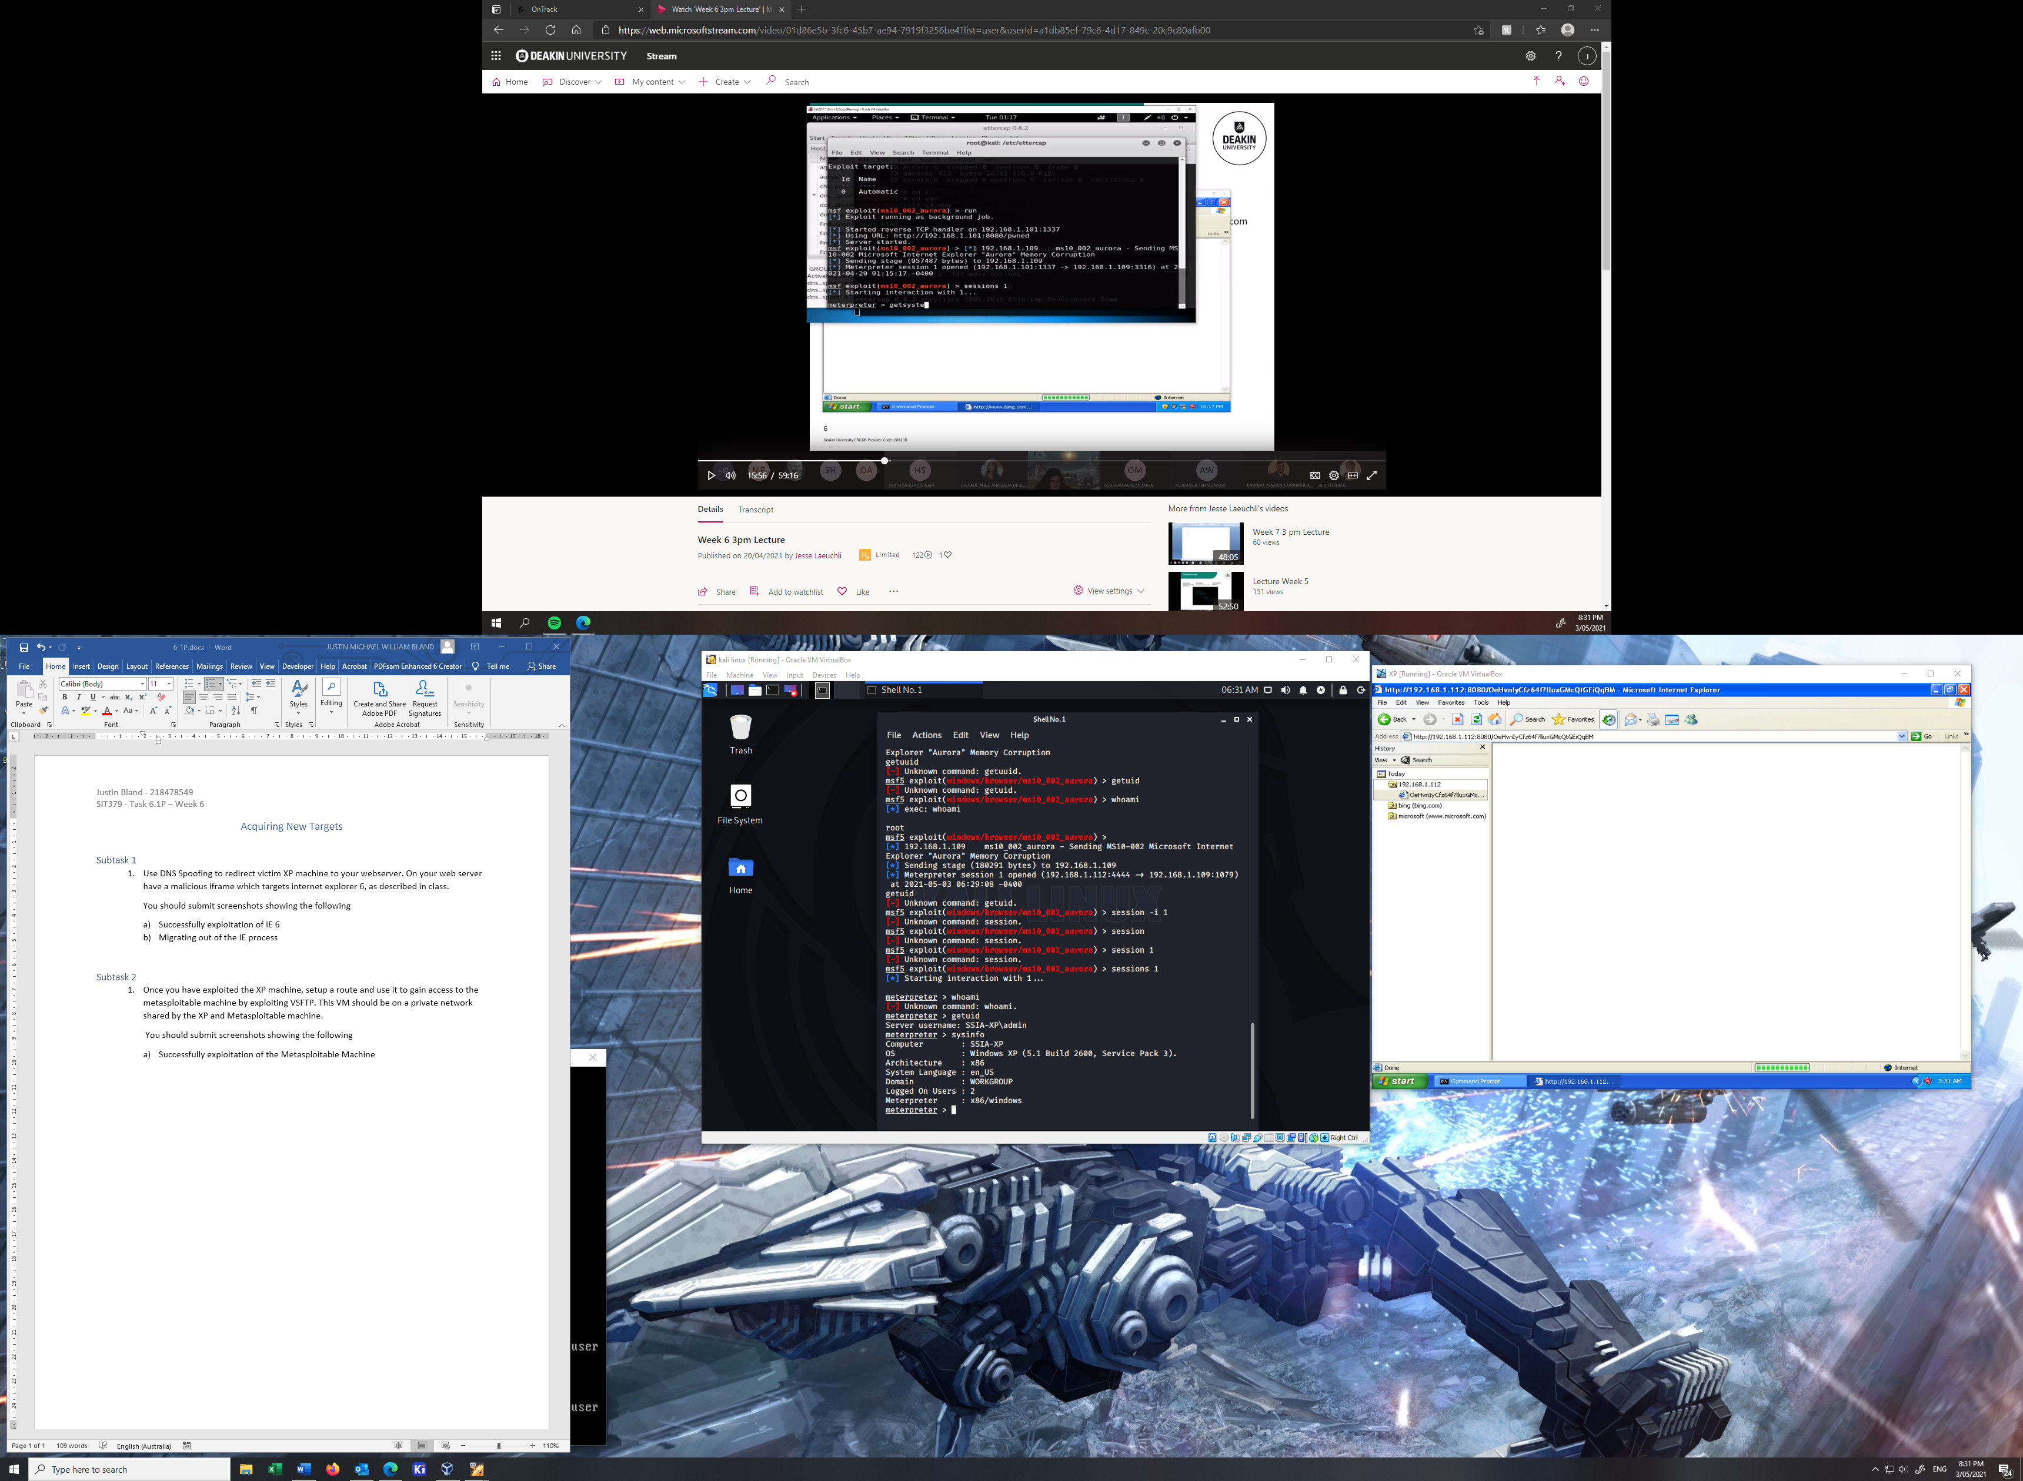

1. Migrating out of the IE process

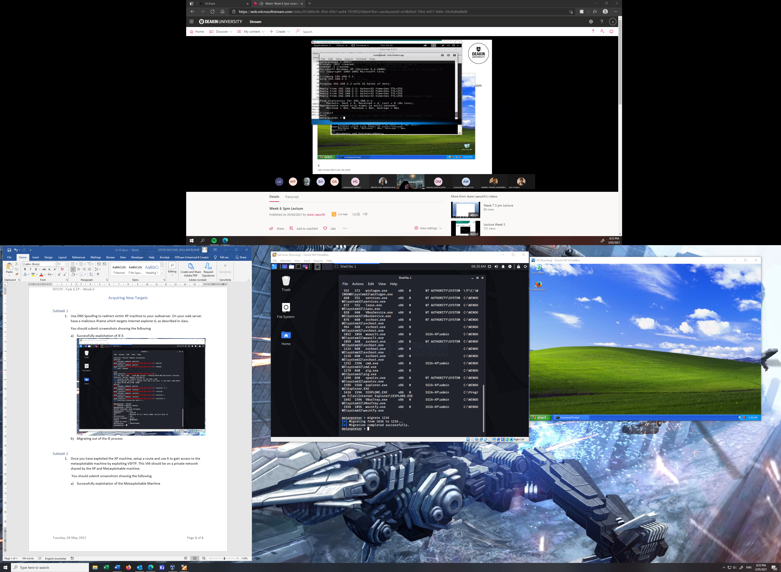

### Subtask 2

1. Once you have exploited the XP machine, setup a route and use it to gain access to the metasploitable machine by exploiting VSFTP. This VM should be on a private network shared by the XP and Metasploitable machine.

You should submit screenshots showing the following

1. Successfully exploitation of the Metasploitable Machine

